Diagnosis Expert System

صورة تحتوي على نص, ترس

تم إنشاء الوصف تلقائياً

**BY:**

RAHAF ALGHAMDI - 1709138

RANEEM ALOMARI - 2006452

ELAF ALGHAMDI – 1911456

**Department of Artificial intelligent**

Artificial Intelligence Fundamentals - CCAI 221

College of Computer Science and Engineering

Jeddah University, SAUDI ARABIA

**Instructor:**

Dr.Aishah blfaqih

**2022**

# 

**Table of Content**

Abstract 4

Introduction 4

Objectives of the study 4

What is a Diagnosis Expert System(DExS)? 4

How can Expert Sestem program applied ? 5

Suggestion solution 5

Screenshots of solving proplem 6

Conclusion 9

Reference 10

|  |  |  |
| --- | --- | --- |
|  | Required Items |  |
| Elaf Alghamdi | Task1: Project Report – description of topic . |  |
| Raneem Alomari | Task2: Coding applied to solving the proposed problem. |  |
| Rahaf Alghamdi | Task3: Clear Presentation for project . |  |

# 

# **Abstract**

Diagnosis Experts Systems are one of the first and most ongoing Artificial Intelligence projects.The agent-based diagnosis expert system for patients (DExS) is developed in this study based on an examination of the issues faced by current public health circumstances, such as the sharp increase in elderly patients, limited medical professionals, resources, and technology. [1]

The installation of the technology will improve the quality of treatment provided to patients. The establishment of the system will make medical condition diagnosis quick and straightforward while also assuring that the diagnosis is correct and dependable. Patients who want to learn more about their health. [2]

# **Introduction**

An expert system is a computer software that mimics the decision-making abilities of a human expert. By doing so, it mimics the behavior of a human expert, using human knowledge to solve problems that would normally require human intelligence. Patients seek medical help for a variety of reasons, including the diagnosis and treatment of a variety of ailments. However, because many other diseases can cause fever, verifying the diagnosis of malaria can be difficult. It could be done to confirm a clinically suspected diagnosis or to gain more detailed information. Infection, for example, may signal the presence of malaria sickness in underdeveloped countries where malaria is widespread and is frequently associated with the "factor of development" known as poverty. Computer-based devices are rapidly being used to optimize the quality of medical services. [3]

# **Objectives of the study**

## What is a Diagnosis Expert System(DExS)?

Expert systems are databases that are designed to mimic (copy) the expertise and knowledge of a human expert on a variety of topics. Human specialists' knowledge is entered and stored in the system. Users of the expert system have the ability to challenge knowledge. The system looks through its database for anything that matches the information given by the user. In the same way, as human specialists can the expert system can provide answers to tough situations. [4] Diagnosis Expert System (DEXS) can substantially aid in the identification of diseases and the description of treatment methods while taking into account the user's ability to cope with and engage with the expert system in a simple and plain manner. [5]

|  |
| --- |
|  |

# How can Expert Sestem program applied ?

The DExS(Diagnosis Expert System) Technique can be applied in consultations since it immediately displays the diagnosis and also clarifies of the obtained results, which is very useful to the professional. The user can interact with a computer to solve an issue using an expert system. Because the expert system can store heuristic knowledge.The proposed system is capable of performing a wide range of tasks. It will reach a conclusion about the diagnosis based on the user's responses to particular questions posed by the system. The questions give the system an explanation for the patient's symptoms, which helps the expert system in diagnosing the illness using an inference engine. It stores the facts and the conclusion of the inference of the system, and the user, for each case, in database. It performs database processing in order to extract rules, which completes the knowledge base. [6]

Generally, diagnosis systems technology's range of applications to solve issues in industrial, commercial, and other industries is so broad that it defies easy categorization. These technologies have been divided into approximately seven types. These include: Diagnosis and Troubleshooting of Devices and Systems of All Kinds; Planning and Scheduling; Configuration of Manufactured Objects from Subassemblies; Financial Decision Making; Knowledge Publishing; Process Monitoring and Control; and Design and Manufacturing. [7]

## **Suggestion solution**

The researchers proposed the construction of the Knowledge-based Expert System for Medical Disease Diagnosis to satisfy the aforementioned needs of the healthcare sector. The technology will aid in the diagnosis of a patient's health status via electronic means. It will use clinical reasoning to arrive at a patient's medical disease diagnosis. The system will increase the quality of patient treatment. The system's development will make medical disease diagnosis quick and easy while also ensuring an accurate and reliable diagnosis. [8]

* Online Expert System with knowledge-based for health Clinics Conceptual framework

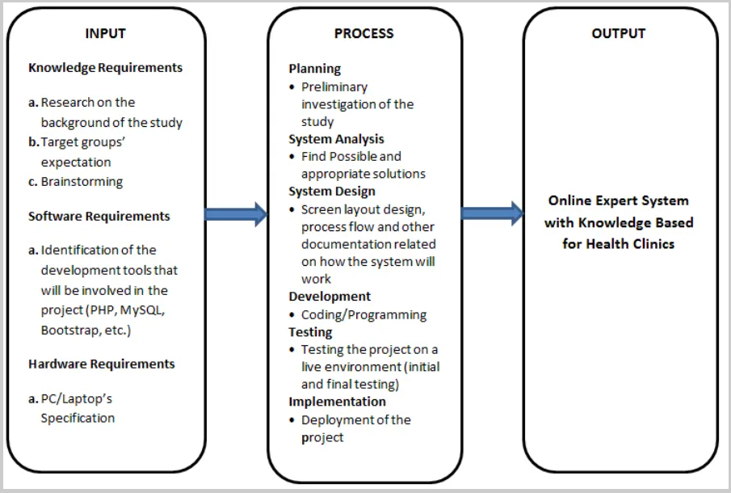

## **Screenshots of solving proplem**

questions on how the diagnosis was reached, and what further investigative action could be taken to focus on a particular diagnostic candidate.

صورة تحتوي على نص

تم إنشاء الوصف تلقائياً

صورة تحتوي على نص, لقطة شاشة, كمبيوتر, كمبيوتر محمول

تم إنشاء الوصف تلقائياً

صورة تحتوي على نص

تم إنشاء الوصف تلقائياً

**The coding**

im_sick:-

guessing(Disease),

write("after checking your symptoms i think u have: "),write(Disease),nl,

write(" thats it take care and remmber Prevention is better than cure "),undo.

guessing(cold):- cold,!.

guessing(flu):- flu,!.

guessing(covid):-covid,!.

cold :-

check(sore_throat),

check(runny_nose),

check(sneezing),

check(shortness_of_breath),

check(cough),

check(nasal_congestion),

check(respiratory_issuse),

check(lossing_appetite),

write("inclubation period is 1-3 days so dont woory just

take panadol , rest and drink hot drinks because "),nl.

flu :-

check(fever),

check(lossing_appetite),

check(chills),

check(headache),

check(body_aches),

check(cough),

check(fatigue),

write("inclubation period is 1-4 days take antiviral drugs 2 time for 5 days,

for watry eays you take antihstamine helpful for your flu,

stay home and u may use cold compresses for the fever because "),nl.

covid :-

check(loos_of_taste/smell),

check(fever),

check(lossing_appetite),

check(chills),

check(headache),

check(shortness_of_breath),

check(cough),

check(respiratory_issuse),

write("inclubation period is 2-14 days

there is no cure discovered just eat well ,sleep well ,

drink plenty of fluids, open windos if u breathless because "),nl.

ask(Q):-

write("dear patient do you have this Symptom: "),

write(Q),write('?'),read(Answer),nl,

((Answer==yes;Answer==y)->assert(yes(Q));

assert(no(Q)),fail).

:- dynamic yes/1,no/1.

check(Symptoms):-

(yes(Symptoms)->true;(no(Symptoms)-> fail;ask(Symptoms))).

undo :- retract(yes(_)),fail.

undo :- retract(no(_)),fail.

undo.

**Query**

**Im_sick.**

**Output**

صورة تحتوي على نص

تم إنشاء الوصف تلقائياً

صورة تحتوي على نص

تم إنشاء الوصف تلقائياً

# Conclusion

Diagnosis systems are more popular among today's youth. The researchers used this information to create a knowledge-based Expert System for Medical Disease Diagnosis. The study's findings revealed that the system was well received by the intended users and respondents. In terms of user acceptability, efficacy, quality, timeliness, and productivity, the majority of target users and respondents are pleased with the system. Regrettably, most databases are proprietary and hard to obtain. Because some hospitals have already been employing computerized record systems instead of old paper-based systems, medical databases should have a bright future. Data generation for machine diagnosis should be relatively simple. This method is generic, knowledge-based, and may be used to diagnose diseases with any rule-based expert system. We intend to expand the capabilities of our expert system by implementing more inference rules for semantic based knowledge representation in the future, as well as perform real user studies with patients and medical professionals. [9]

# Refrence

|  |  |
| --- | --- |
| [1] | "Agent-based intelligent medical diagnosis," 2015. [Online]. Available: https://content.iospress.com/download/technology-and-health-care/thc976?id=technology-and-health-care%2Fthc976. |
| [2] | "Medical Diagnosis Expert System for Malaria and Related Diseases for Developing Countries," 2018. [Online]. Available: https://www.scirp.org/journal/paperinformation.aspx?paperid=86252. |
| [3] | "An expert system - E-Health Telecommunication," 6 June 2018. [Online]. Available: https://www.scirp.org/journal/paperinformation.aspx?paperid=86252. |
| [4] | "An Expert System for Diagnosis of Human Diseases," November 2010. [Online]. Available: https://citeseerx.ist.psu.edu/viewdoc/download?doi=10.1.1.206.4184&rep=rep1&type=pdf. |
| [5] | "Medical Diagnosis Expert System," 7 July 2018. [Online]. Available: https://www.researchgate.net/publication/326628067_Medical_Diagnosis_Expert_System_for_Malaria_and_Related_Diseases_for_Developing_Countries. |
| [6] | "What is Expert System in AI (Artificial Intelligence)? with Example," 8 March 2018. [Online]. Available: https://www.guru99.com/expert-systems-with-applications.html. |
| [7] | "Technology development and commercial applications of industrial fault diagnosis system," Februar 2022. [Online]. Available: https://www.researchgate.net/publication/355384113_Technology_development_and_commercial_applications_of_industrial_fault_diagnosis_system_a_review. |
| [8] | "Online Expert System with Knowledge Based Application for Health Clinics," 20 November 2018. [Online]. Available: https://www.inettutor.com/source-code/online-expert-system-with-knowledge-based-application-for-health-clinics/. |
| [9] | "A Generic Knowledge Based Medical Diagnosis Expert System," 2021. [Online]. Available: https://arxiv.org/pdf/2110.04439.pdf. |